ADDING NEW MAGAZINE ISSUES TO YOUR WEBSITE’S MAGAZINE NEWS STAND PAGE
To add new titles to your magazine rack, get the direct, unique URL for the issue. That is the main URL for the title PLUS a character string like this - ?selDate=20171031 - with the digits being the publication date.
For example, this magazine’s (Southern Indiana Business Magazine) main URL is:
http://southernindianabusinesssource.cnhi.newsmemory.com/ and the pub date is October 31st, 2017, so the unique URL for that issue is: http://southernindianabusinesssource.cnhi.newsmemory.com/?selDate=20171031
Get an image file prepared for your cover preview. It should be a JPEG that’s cropped to the cover dimensions. (NO CROP or REGISTRATION MARKS.)

A new LINK ASSET has to be created in BLOX for each new issue.
In BLOX, go to EDITORIAL and select NEW ASSET. Choose the menu options shown in this shot.

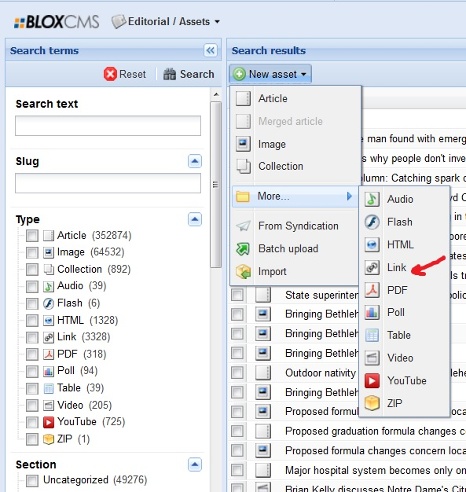

Follow the directions shown here to create your new LINK asset.
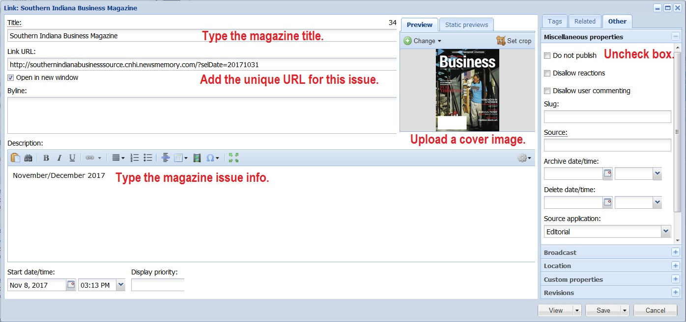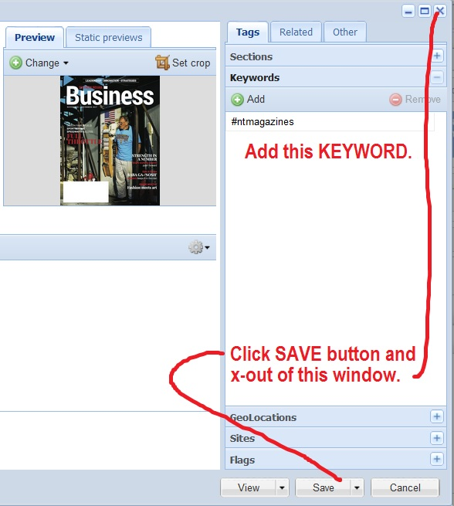
If you’ve done this correctly, the block query rules set up for the MAGAZINE NEWS STAND page should pull in your new asset(s).

